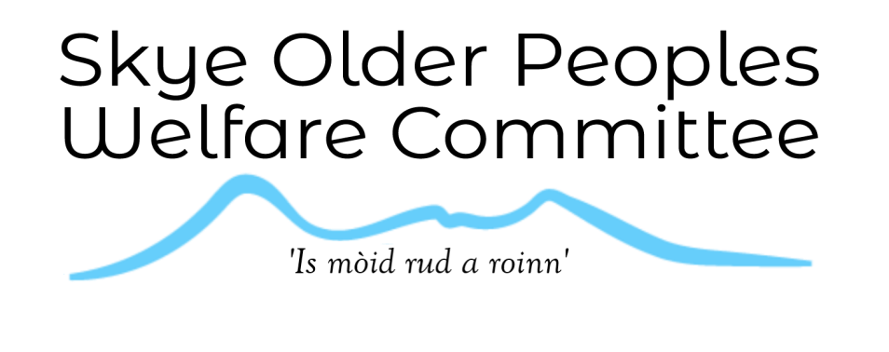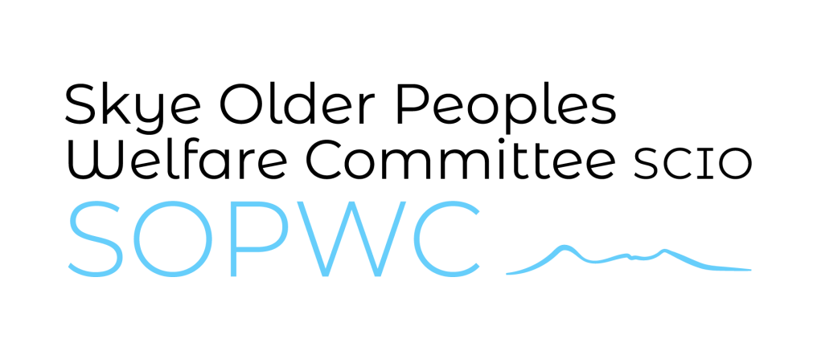

Budhmor Fund Application Form

Applications for up to £500 only require Section A to be completed. Application for between £500 and £5,000 require section B to be completed also.

|  |  |
| --- | --- |
| Details of Applicant | |
| Name of Group / Applicant: |  |
| Address:  Postcode: |  |
| Phone: |  |
| Email: |  |

|  |  |
| --- | --- |
| Section A Fund Details | |
| Title / nature of project: | - |
| Total amount Required: | - |
| Amount requested from Budhmor Fund: | - |
| Anticipated start date / Date of event. | - |

|  |  |
| --- | --- |
| Section B Fund Details >£500 - £5000 | |
| ‘Match Funded’ Sources: | - |
| Match Funded amounts: | - |
| Own Contribution: | - |
| Date evidence can be provided: (Money will not be released until match funding is evidenced) | - |
| Anticipated date of project completion: | - |

**Description of Project**

**Describe the project in brief:**  
*Please include: qualifying criteria of Older Adults, objectives, any equipment that may be purchased.*

**Detail any purchases that are anticipated to be over £100:**

Name: _____________________________

Signature : ­_____________________________

Date: _____________________________

Thank you for completing this application form. If you have any supporting documents then please attach these to the email or enclose them in the envelope.

Please submit your applications by email to [budhmorfund@gmail.com](mailto:budhmorfund@gmail.com)

Or send a printed application to: Tigh na Drochaid, Bayfield, Portree, Isle of Skye, IV51 9EZ